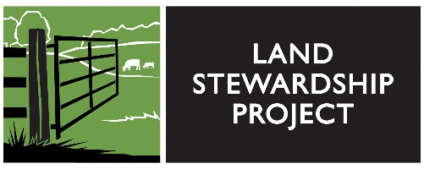
Farmland Ownership
and Rental:
Managing for Stewardship

Owner/Renter Discussion Tips 2/1/18

A formal written agreement is much easier to create when you are starting out fresh with a new renter. It’s harder when you have a years-long informal agreement with a renter to suddenly start demanding changes in soil management. How do we get a renter to agree to certain practices when the relationship is based on an informal handshake. How does one transition it to a written agreement?

- Project humility. Validate at least some parts of what the renter is saying. They aren’t just proud of how cheaply they can do things. They are also proud of how innovative they can be.

- Start with what’s working and what’s working well. E.g., “thanks for clearing the snow from my mother’s driveway.” Feel free to tell farmer that they do certain things very well, like cover cropping, crop rotations, etc. Don’t just dwell on what the farmer is doing wrong.

- Is there a way to bring up, “I admire the practice you use on your land, can you use it on mine?” What are you (renter) most proud of about the way the farmland you own is cared for?

- Respond to negativity with “Conservation is an opportunity—it’s not a negative thing.” If you are going to have a long-term relationship with the renter, it is to the renter’s benefit to build soil health, since they will have less fertilizer and soil washing away.

- Just start the conversation about soil health. As a landowner I want to approach this like owning a car. If I don’t take care of my car, it will wear out. I’ve been thinking about my farmland and how I would like it cared for. Here is what is important to me……. I’ve also like to think about how it could be even better cared for. (or phrase as appropriate to circumstance). One (or more) thing I’ve heard about is ……

- The goal is to help the renter be proud of taking good care of one’s land.

- Recognize these may be additional steps that may entail time and at least initial additional costs. “What would you need from me to take these additional steps, or here is what I am offering?” Some things farmers get reimbursed, some things not. Find out what that might be and negotiate on it. Perhaps offer to split the cost-share that is the farmers responsibility.

Why should the renter pay for soil improvements? A renter of a house doesn’t pay for a new roof, the home owner does. Answer: The renter may be getting the benefits of government farm programs like CSP, crop insurance and EQIP, so at the least should split the cost of putting in place practices that fall under such programs, etc.

Words to Use
If “cover crops” doesn’t resonate, try bringing up winter rye (or a specific species combination) rather than the more general term.

Words Not to Use
You are doing it wrong. Tolerable soil loss or T-value. It’s all about economics.

