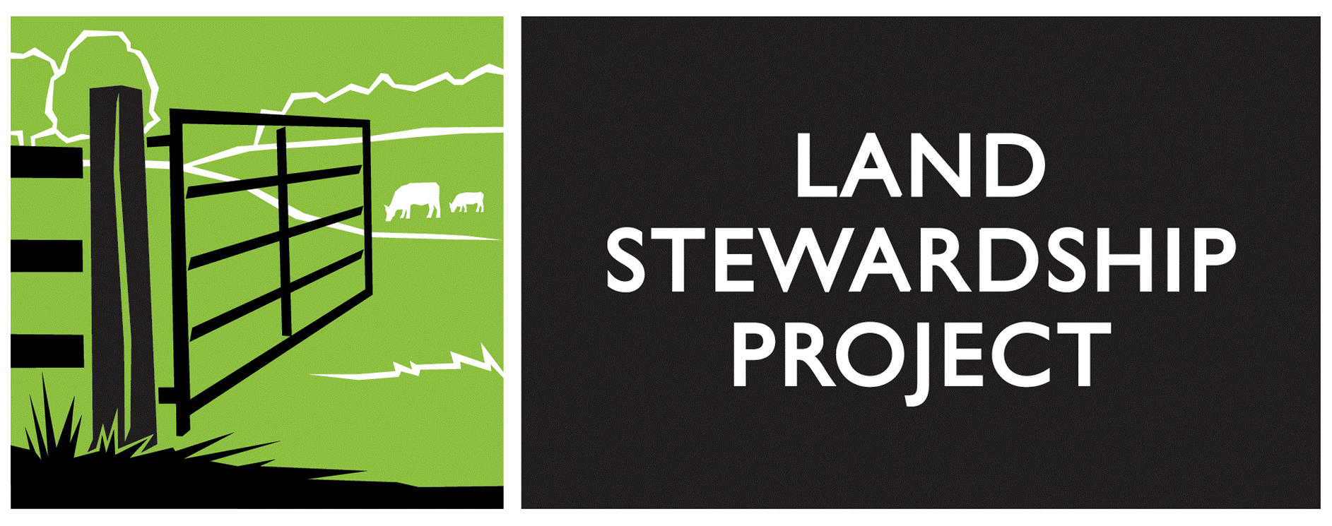

FARM BEGINNINGS

Application 2019-2020 – Menomonie, WI

Name (Primary Contact): _______________________________________________________________

Address: ____________________________________________________________________________

City: ___________________________________________________ State: _____ Zip: ____________

Ph#: (h) _________________________ (w) _________________________ (cell)___________________

May we call you at work? Yes *or* No Best time to call: ____________________________________

E-mail Address: _______________________________________________________________________

How did you hear about Farm Beginnings (please mark box and list a specific source)?

|  |  |  |  |  |  |  |  |  |  |  |  |
| --- | --- | --- | --- | --- | --- | --- | --- | --- | --- | --- | --- |
| Internet |  | Magazine |  | Newspaper |  | Conference/Event |  | Word-of-Mouth |  | Other |  |

Specific source in relation to above: _________________________________________________

Have you attended Farm Dreams? Yes or No

Will you be applying for a scholarship? Yes *or* No

Will you be applying for the MN Beginning Farmer Tax Credit (more info: <https://www.mda.state.mn.us/sites/default/files/2018-06/ag03360bftcx.pdf>)? Yes or No

Do you have any special needs we should know of? ___________________________________________

Name (Farming Partner): _________________________________________________________________

Address: ______________________________________________________________________________

City: __________________________________________________ State: ________ Zip: ______________

Ph#: (h) _______________________ (w) ________________________ (cell)________________________

E-mail Address: _________________________________________________________________________

**EACH APPLICANT must answer the following questions. If you need more space, attach additional sheets.**

Why are you interested in farming?

What are you currently doing?

Please list ALL agricultural experience or training you have received so far (**include conferences, workshops, internships, employment, field days, farm tours, volunteer positions, etc…**)**:**

**The following questions can be answered JOINTLY, or SEPARATELY by both applicants:**

What are your future farming goals:

1-5 years:

5-10 years:

How do you think Farm Beginnings can help you move toward your farming goals?

What do you see as your biggest obstacle in starting your own farm enterprise?

Which farming enterprises are you considering (**Rank your top 3 choices by marking #1, #2, #3**):

dairy ___ beef ___ sheep ___ goats ___ hogs___ crops & hay___ vegetables ___

flowers ___ fruit ___ poultry ___ other __________________________

Check the statement that best describes your access to land for your current or future farming enterprises:

I do not have access to land. _____

I have access to rented land. _____

I own land. _____

Please list any additional questions or considerations you have about the Farm Beginnings program.

# PERSONAL ASSESSMENT

Rate Your Farming and Business Skill Levels

|  |  |  |
| --- | --- | --- |
| **No experience** | **Some Exposure** | **Competency** |
| **1** | **2** | **3** |

|  |  |  |
| --- | --- | --- |
| **KNOWLEDGE & SKILLS** | **Rating (1,2,3)** | |
| **Applicant 1** | **Applicant 2** |
| **Production** |  | |
| Goal setting |  |  |
| Acquiring land (e.g., rent, lease, purchase) |  |  |
| Developing production, marketing & financial plans |  |  |
| Maintaining and repairing tools & equipment |  |  |
| Maintaining & repairing infrastructure |  |  |
| Managing soil fertility |  |  |
| Managing pests, weeds & diseases |  |  |
| Managing pastures |  |  |
| Feeding & watering animals |  |  |
| Monitoring & treating animal health problems |  |  |
| Managing manure |  |  |
| Preparing a crop production plan |  |  |
| Operating equipment & implements safely |  |  |
| Seeding, planting & harvesting |  |  |
| Post-harvest handling & storage |  |  |
| **Financial Management** |  |  |
| Setting up bookkeeping & record-keeping systems |  |  |
| Record keeping (e.g., financial, production, sales) |  |  |
| Preparing financial statements & tax forms |  |  |
| Bookkeeping; paying bills & taxes |  |  |
| Monitoring cash flow |  |  |
| Managing debt |  |  |
| Strategic planning |  |  |
| Grant research and/or fundraising |  |  |
| **Marketing** |  |  |
| Market research |  |  |
| Networking |  |  |
| Developing promotional materials and advertising |  |  |
| Proper communication with customers/buyers |  |  |
| Selling farm products & services |  |  |
| Web design and social networking |  |  |

# APPLICATION CHECKLIST

# *To streamline our application process, please refer to the following:*

# Farm Beginnings’ Application Packets must be completed and sent to: Land Stewardship Project

# Attn.: Karen Benson-Farm Beginnings

# PO Box 130

# Lewiston, MN 55952

# Applications will only be accepted via the U.S. Postal Service (no electronic or faxed applications will be reviewed).

# Only complete Application Packets (see checklist below) will be reviewed.

* **A $200 deposit is required (please make check out to Land Stewardship Project).**
* **The application deadline is POSTMARKED SEPTEMBER 1st.**
* **EARLY BIRD DISCOUNT of $100 will apply to applications received by August 1st.**
* **Applicants will be notified via e-mail or phone by or before September 30 of acceptance into the program.**
* **Applicants will be notified via e-mail or phone by September 30 of scholarship awards.**
* **Correspondence will be sent to the “primary” applicant only.**

|  |  |  |
| --- | --- | --- |
| **Does your Application Packet Include:** (make a checkmark to verify) | | |
|  | Farm Beginnings Application | |
|  | Personal Assessment | |
|  | $200 Deposit Check | |
|  | Scholarship Application forms (if applicable): | |
|  | Statement of Need |
|  | 2 References  **for each applicant** |
|  | 2018 Tax Return  **for each applicant, if not filed jointly** |
|  | Net Worth Statement  **for each applicant** |

***\*\*Please complete this checklist and include it with your application\****

**www.landstewardshipproject.org**