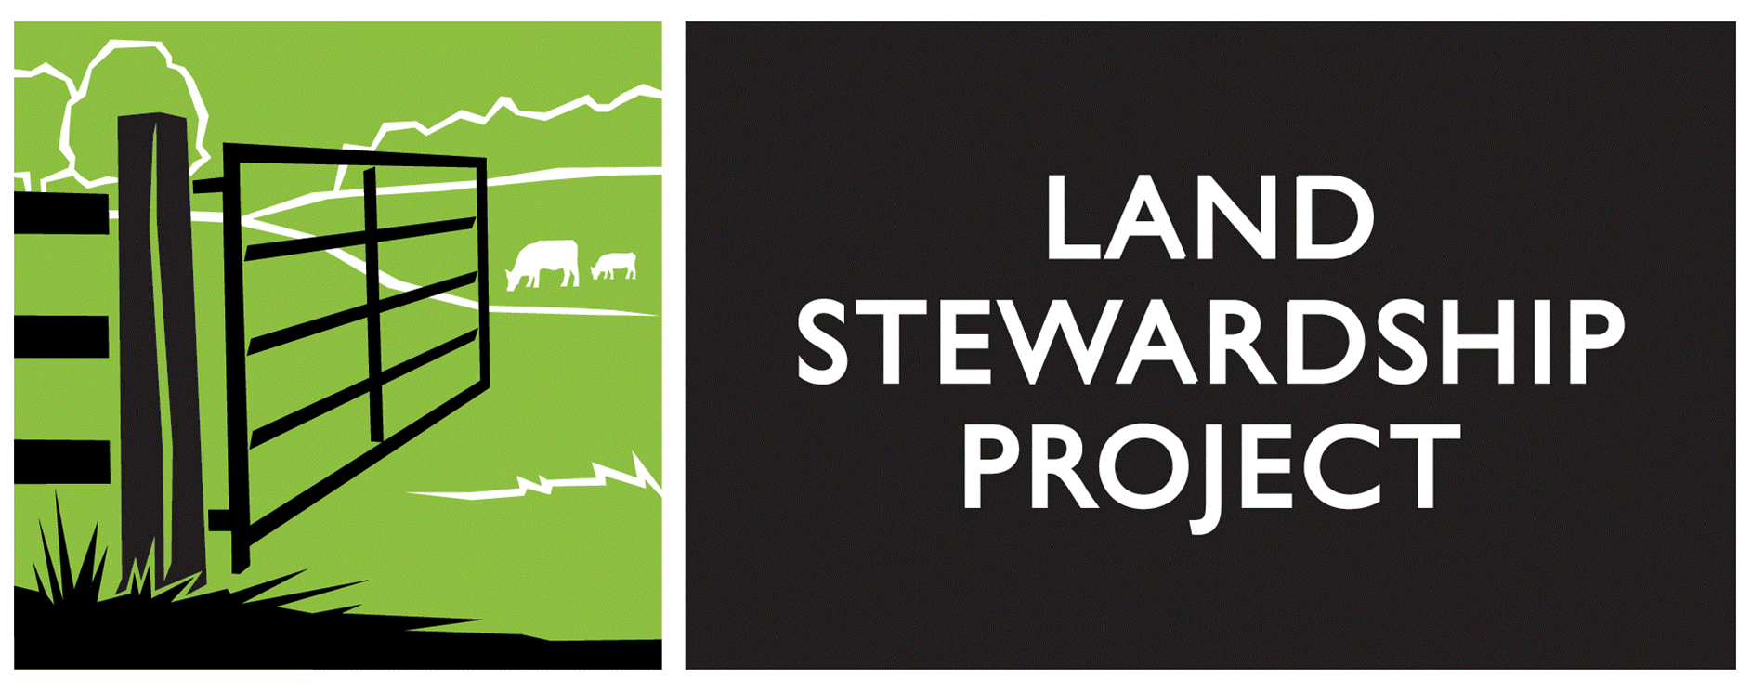
JOURNEYPERSON COURSE
2019-2021 APPLICATION

The Journeyperson Course application deadline is October 20, 2019. Applicants will be notified of acceptance as soon as the applications are reviewed. There are only 6 spots available in this year’s course so apply as soon as you can to ensure your spot. A $200 refundable deposit is due with this application. Contact Amy Bacigalupo with questions or to review if the course is right for you at amyb@landstewardshipproject.org or 320-269-2105.

Name (Primary Contact):

Address:

City: State: Zip:

Email Address:

Phone: (h) (w) (c)

May we call you at work? Yes No

Best time to call:

How did you hear about the Journeyperson Course?

Internet |  | Magazine |  | Newspaper |  | Conference/Event |  | Word of mouth |  | Other

Specific source in relation to above:

Name (Farming Partner, if Applicable):

Address:

City: State: Zip:

Email Address:

Phone: (h) (w) (c)

Do you or your partner (if applicable) have any special needs we should know (dietary, other)?

Journeyperson Application: Background Information, Farm Overview, and Business Goals
______________________________________________________________________________

1. Name of Farm Business:

2. Location of Farm Business (City, State, County, Township):

3. Check the statements that best describe your access to land for your current farm operation:

_____ I do not have access to land
_____ I have access to rented land
_____ I own land
_____ I will need more land within the next 3-5 years
_____ I may need more land in the future

4. Provide your farm resume: education, production experience, financial management experience, marketing experience and any related experiences.

5. Provide a brief, general overview of your current farming operation and farm enterprises.

6. Provide a brief, general overview of your goals for your farm and farming enterprises in the next 5 years.

7. Please provide your Holistic Goal or Quality of Life statement (if you haven’t written a Holistic Goal or quality of life statement, share aspects of quality of life that are most important to you).

8. Check the statement(s) for yourself and your partner (if applicable) that comes closest to describing your current average workload:

Yourself: A) I farm _____ part-time or _____ full-time while also maintaining
_____ part-time or _____ full-time off-farm work.

B) I farm _____ part-time or _____ full-time with no off-farm work.

C) I work _____ part-time or _____ full-time off-farm and do not farm.

D) _____ I maintain seasonal employment that compliments my farming.

Notes:

Partner: A) I farm _____ part-time or _____ full-time while also maintaining
_____ part-time or _____ full-time off-farm work.

B) I farm _____ part-time or _____ full-time with no off-farm work.

C) I work _____ part-time or _____ full-time off-farm and do not farm.

D) _____ I maintain seasonal employment that compliments my farming.

Notes:

9. Describe your future goals for yourself and your partner (if applicable) for your farm and
off-farm workload. When would you like to realistically reach these goals?

10. How much volunteer, intern/apprenticeship, family (besides you and your partner) and hired labor do you currently use on your farm?

11. What is your farm’s projected gross income for 2017?

12. Please indicate the % of gross income that accounts for these categories of expense:

_____ % of gross farm income reinvested in farm capital improvements or assets.
_____ % of gross farm income used for personal / household living expenses.
_____ % of gross farm income used for farm operational expenses.

Notes:

13. Describe your future financial goals for yourself and your partner (if applicable) for your farm and off-farm income. When would you like to realistically reach these goals?

14. What is the total land base (including house and buildings) of your farm and how many acres are in production?

15. Describe 3 areas within your farming enterprises or farm business management that you could use help developing further.

16. Are you currently working with any financial advisors or production mentors? If yes, please list the affiliation (i.e. MOSES Mentorship Program, Farm Business Management, et cetera).

17. Please list any questions or considerations you have about the Journeyperson Course?

THE APPLICATION DEADLINE IS OCTOBER 20, 2019

Journeyperson applications must be completed and submitted to:

Amy Bacigalupo

amyb@landstewardshipproject.org

or by mail at

Land Stewardship Project
Attn: Amy Bacigalupo

117 S. 1st Street

Montevideo, MN 56265

Your application is not complete until the $200 deposit is received. If you have questions regarding the application, email or call Amy at 320-269-2105.

A $200 DEPOSIT IS REQUIRED. IF ACCEPTED INTO JOURNEYPERSON, THE DEPOSIT WILL APPLY TO YOUR $1200 TUITION. IF YOU ARE NOT ACCEPTED, YOUR DEPOSIT WILL
BE RETURNED OR REFUNDED. MAKE CHECKS PAYABLE TO LAND STEWARDSHIP PROJECT.

